7.1.16 The institutional functioning is as per professional code of prescribed / suggested by statutory bodies / regulatory authorities for different professions. (Yes)

Certificate of Affiliation

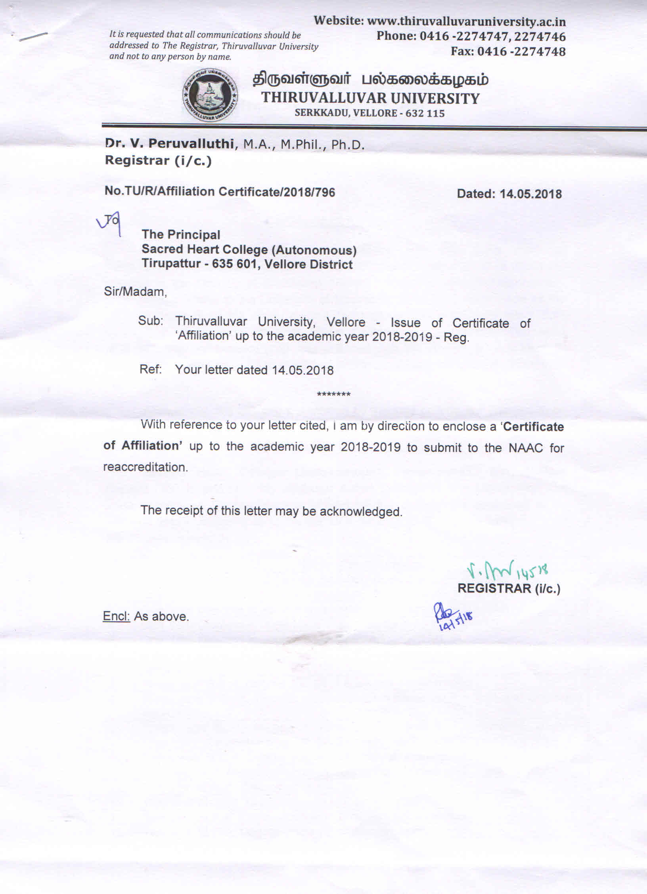

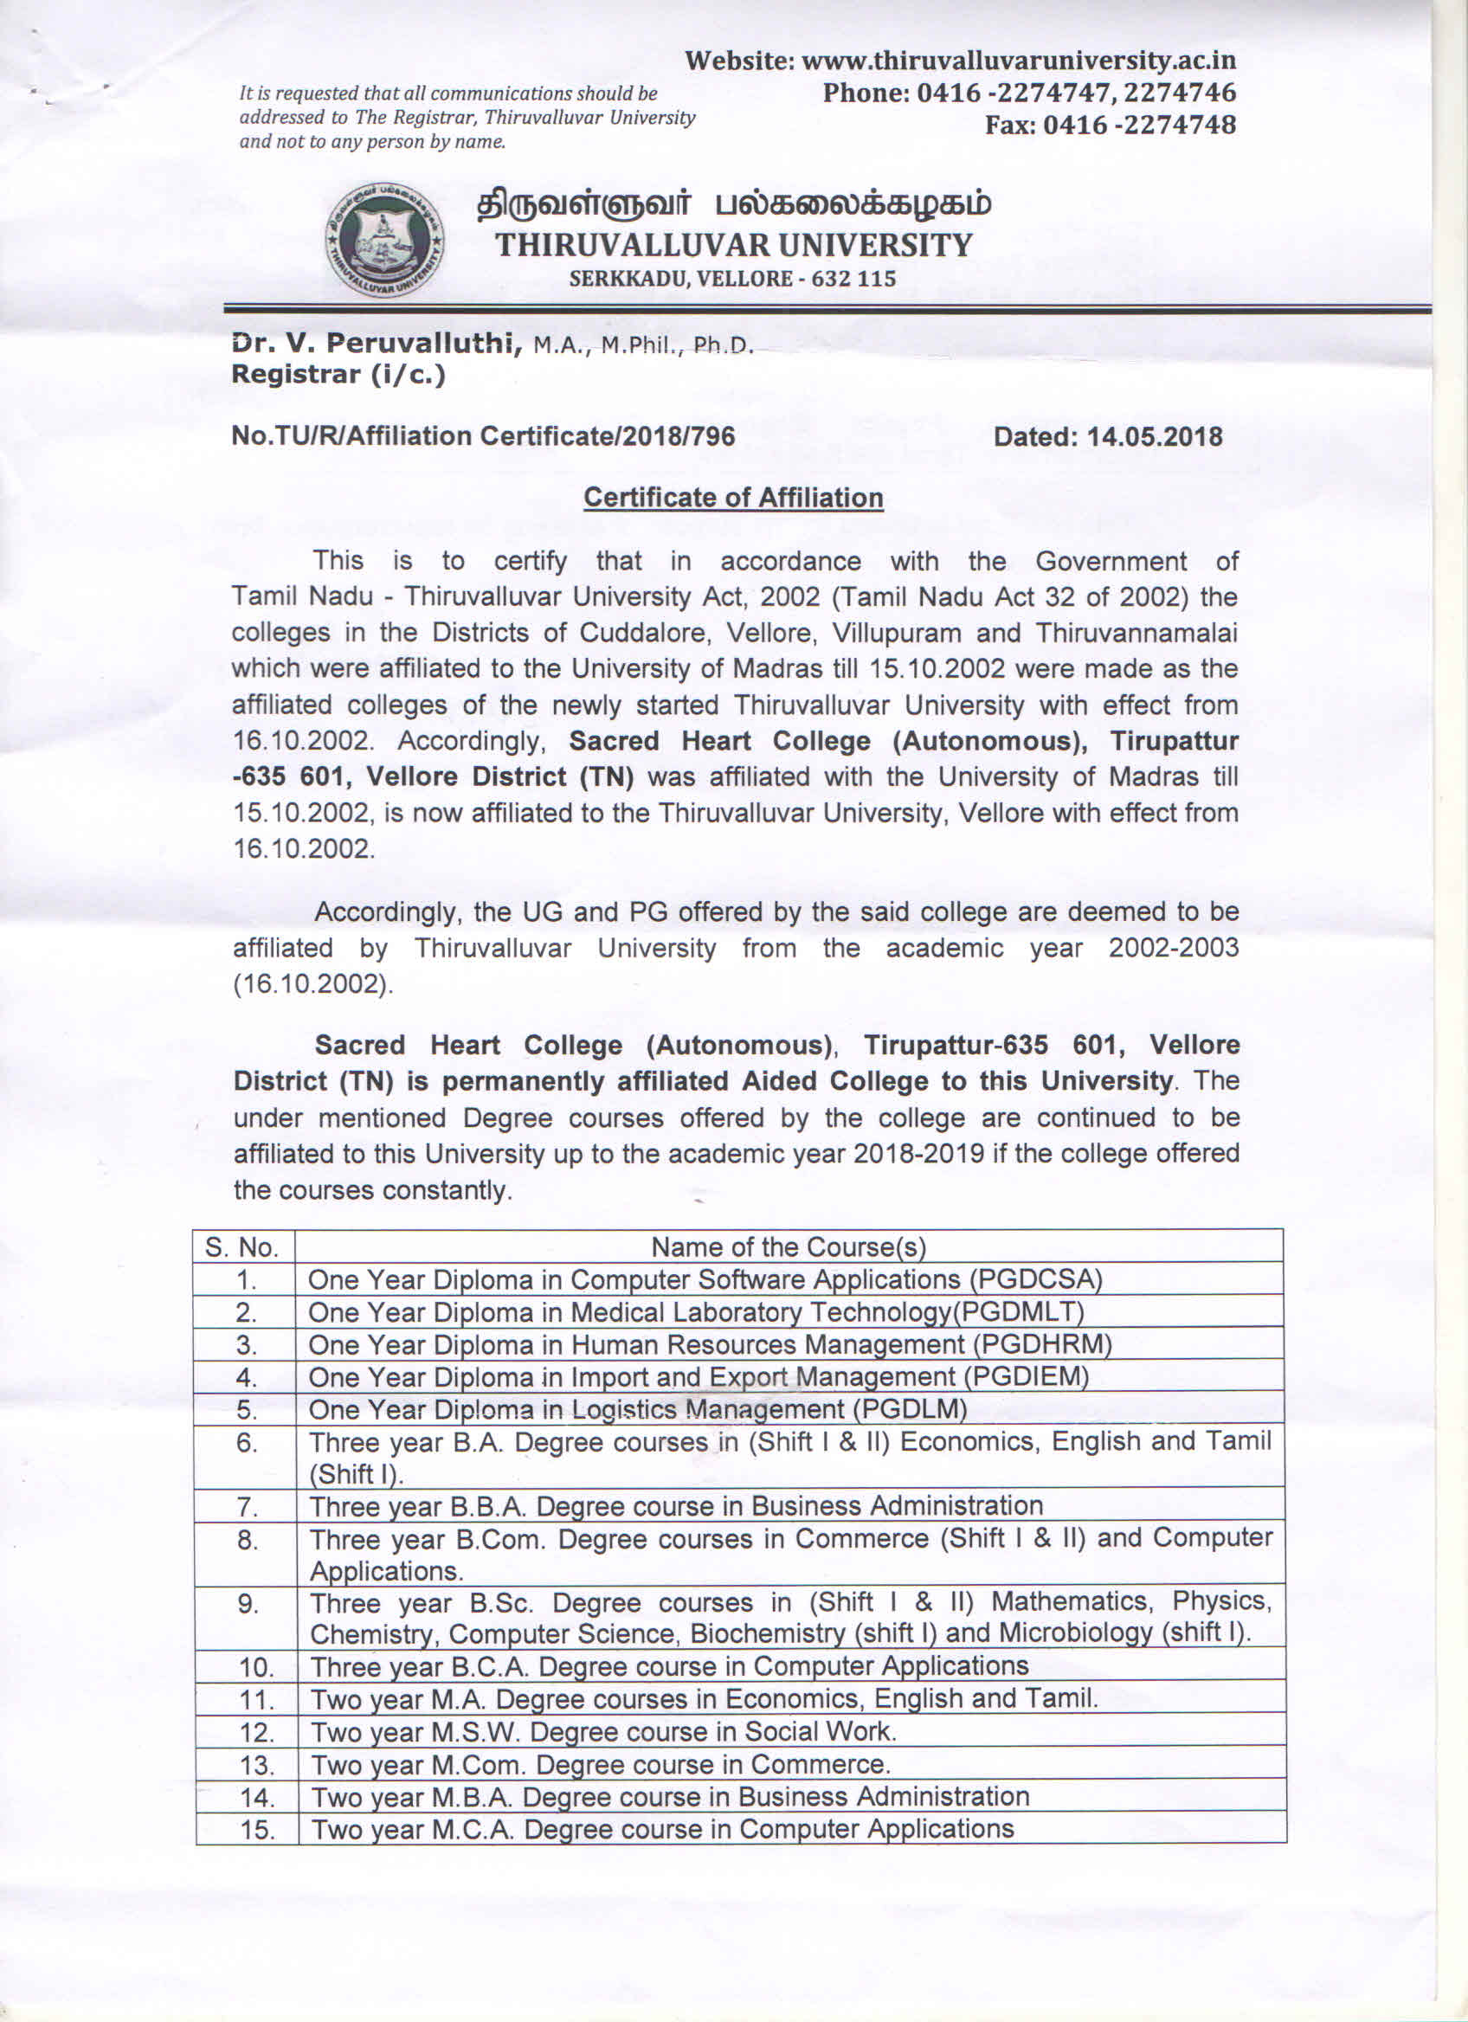
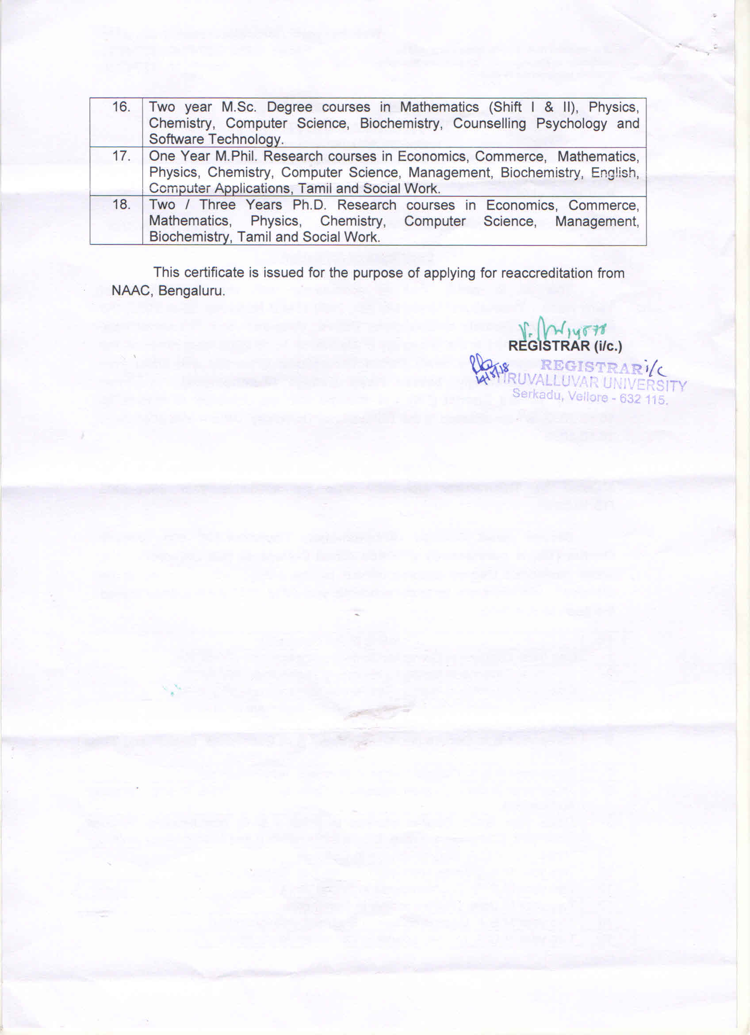
Autonomy Letter
