**2.3 - Teaching- Learning Process**

**2.3.1 - Student-centric methods such as experiential learning, participative learning and problem-solving methodologies are used for enhancing learning experiences:**

**Response:**

|  |
| --- |
| DSC_0221 |

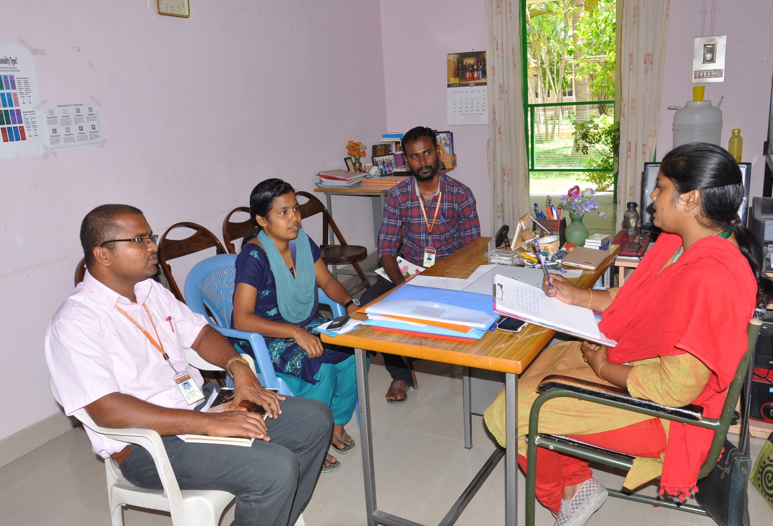 **Family Counseling Centre**

|  |
| --- |
|  |
|  |

.

**Session for Problem Solving**

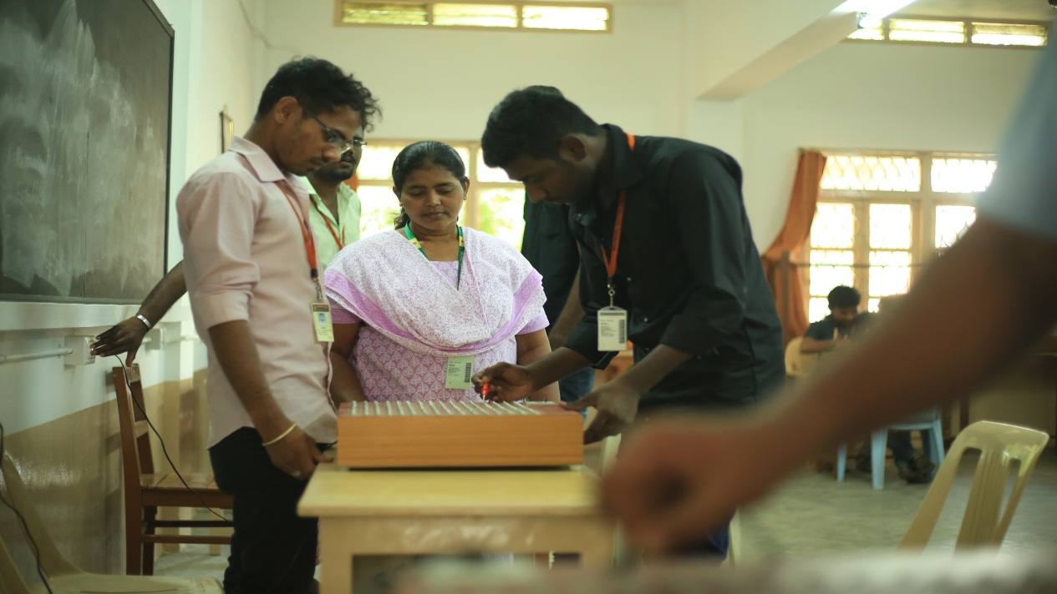

|  |
| --- |
|  |

**Psychometric Tools**

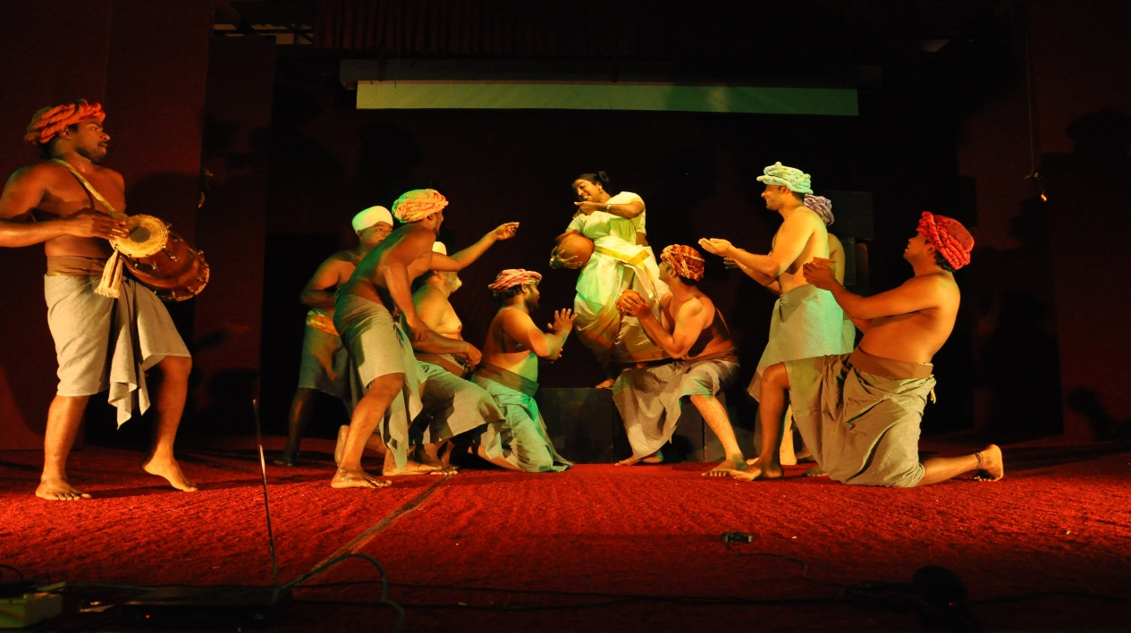

**Alternate Theatre**

**LABORATORY DEMONSTRATION**

|  |
| --- |
| DSC_0538  **Biochemistry Laboratory**  DSC_0606chlab5 |

**Chemistry Laboratory Computer Science Laboratory**

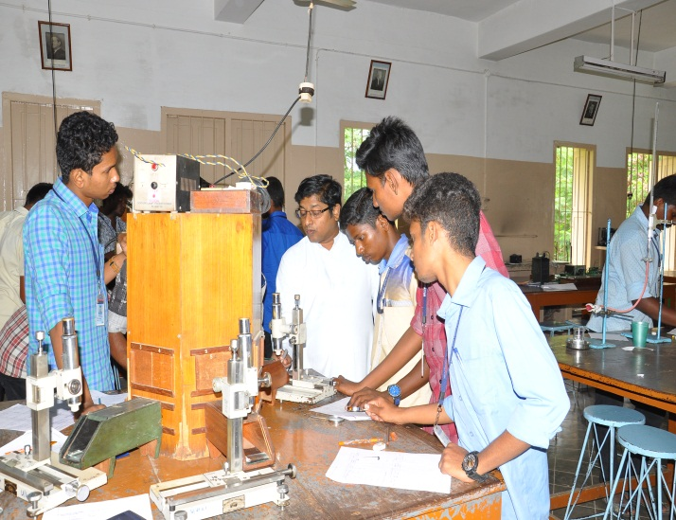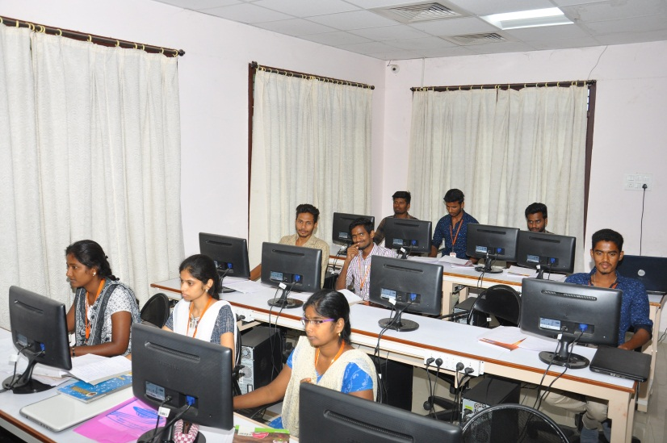

**MCA Laboratory Physics Laboratory**

|  |
| --- |
| **DSC_0144**    **Drama in English**  DSC_0240  **Drama in English** |
| DSC_0210  **Promoting Reading Skill (English)**  DSC_0260 |

**Group Discussion**

|  |
| --- |
| DSC_0291**Group Discussion** |