CLASS QUALITY CIRCLE
Sacred Heart College (Autonomous), Tirupathur Dt
2025 – 2026

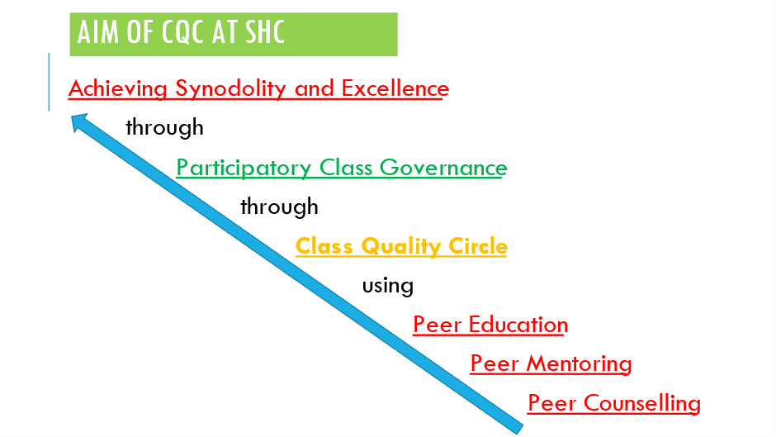

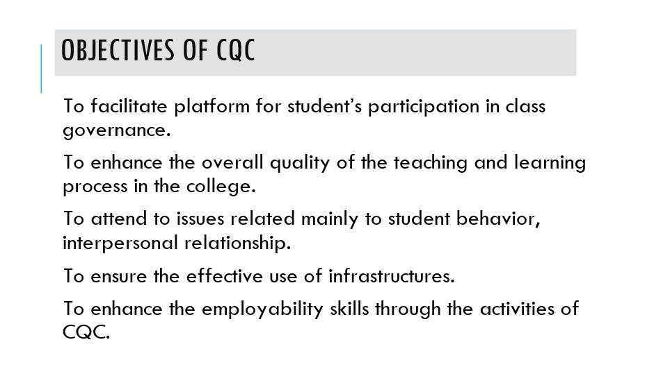

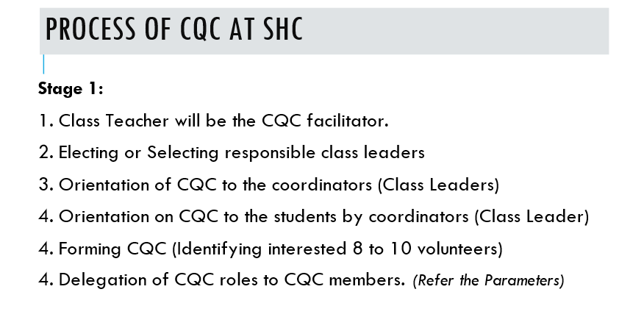
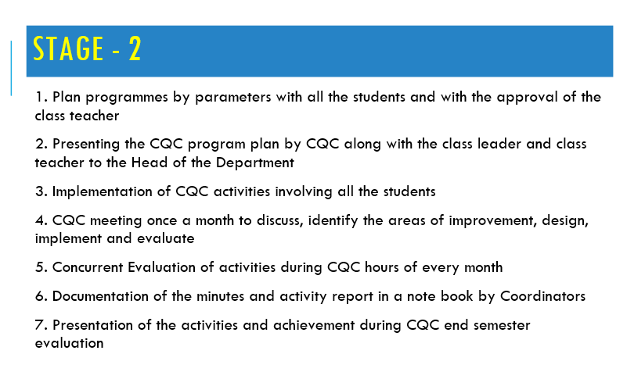

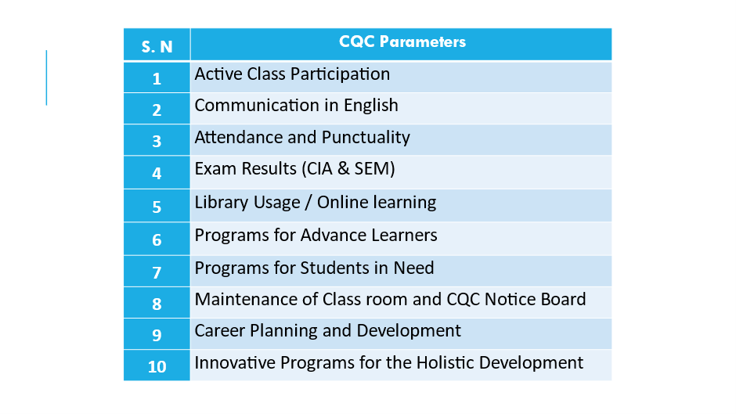
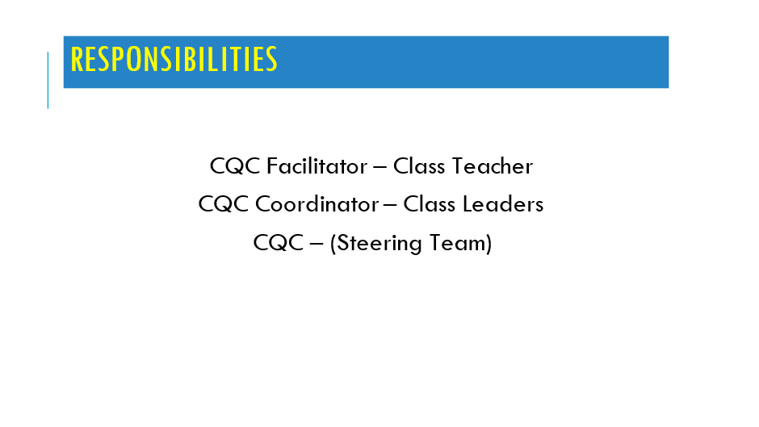
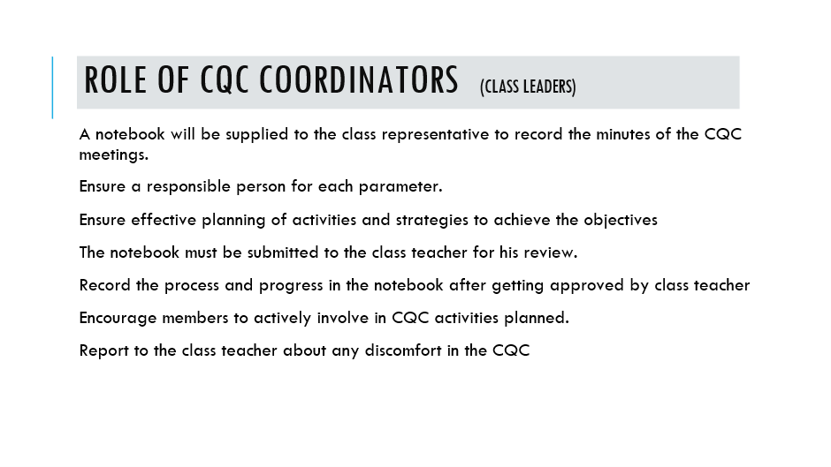

SHC - CQC PARAMETERS (2025-2026)
Tips for activities under each parameter of Class Quality Circle. This list is just to facilitate. You can go beyond the given list. The CQC can decide to propose using any of the below given activities.
1. Active Class Participation
- Enabling students to effectively interact during the class
- Allotting students to summarize previous day learning before each class
- One minute talk by a student just before every class
- Helping teachers for better teaching and learning environment
- Identifying and guiding students who need to participate in the class
- Conduct quiz on the details displayed in CQC noticeboard.

2. Communication in English
- Introducing a language monitoring card/tag
- Encourage members to speak only in English language
- Display of English vocabularies
- News Reading/Movie/Book review presentation in English
- One minute pep talk in English just before each class

3. Attendance and Punctuality
- Maintaining students’ attendance and leave taking records
- Helping late comers to be punctual
- Identifying and Preventing students from dropout/absenteeism through peer counselling
- Ensuring the submission of assignments on time
- Discussing with class teacher about regular late comers and long absentees
- Intimation and reminder about applications for exams and scholarships
- Maintenance of leave letter and permission seeking letter

4. Exam Results (CIA & SEM)
- Identifying students in need for special attention
- Organizing Group Study for the students with arrears
- Model test within the group
- Preparing and sharing of learning materials/notes
- Learning and sharing of materials from reliable internet sources
- Ensuring all pass in CA and Semester examinations

5. Library Usage / Online learning
- Plan for library hour/day for the class
- Book reviews/News Presentation
- Keeping a catalog of recent books for reference
- Participating in Moodle Platform for discussion, quiz, etc.
- Sharing of important websites to learn subject or career development
- Undertake online personality and career tests
- Maintaining a library register for the class
- Membership in other libraries
6. Programs for Advanced Learners

- Taking up online courses for extra learning (NPTL)
- Apply for research grants and fellowships
- Taking up mini projects
- Write and publish research papers and books
- Taking up short field/industry visits and sharing
- Presentation of emerging best practices
- Creating alumni network
- Preparing placement brochure for the department
- Write a periodical newsletter with the association activities
- Create a directory of eminent alumni
- Attending conferences and workshops
- Involving in volunteering programs outside class hours
- Writing competitive exams
- Attending conferences and workshops

7. Programs for the Students in Need

- Identifying students in need (Academic and nonacademic)
- Peer Mentoring for each student
- Model Examinations
- Circulating model question papers
- Supplementary Classes (Peer education)
- Referring group member with problems in studies to college student counsellor.
- Guiding the students (peer counselling)
- Representing students’ grievances and requirements to the class teacher

8. Maintenance of Class Room and CQC Notice Board

- Prepare an inventory of the facilities available in the class room
- Identify and report the issues in the infrastructure
- Ensure the cleanliness of the class room
- Display of information on the CQC notice board (subject / career)
- Display the class achievements on the notice board
- Display of information on competitions, conferences

9. Career Planning and Development

- Display of job opportunities in class notice board
- Review of eminent persons related to the subject
- Arranging Career guidance program with alumni online
- Prepare Resume and upload in job portals
- Arrange Mock Interview sessions
- Undertake online personality and career test

10. Other Creative Programmes for Holistic Development
Any innovative program

