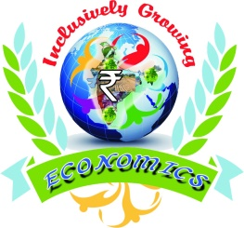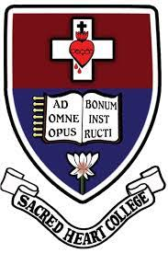

**Sacred Heart College (Autonomous), Tirupattur**

**Post Graduate and Research Department of Economics**

Organizes

Workshop on

**Research Methodology in Social Sciences**

24-25 August 2018

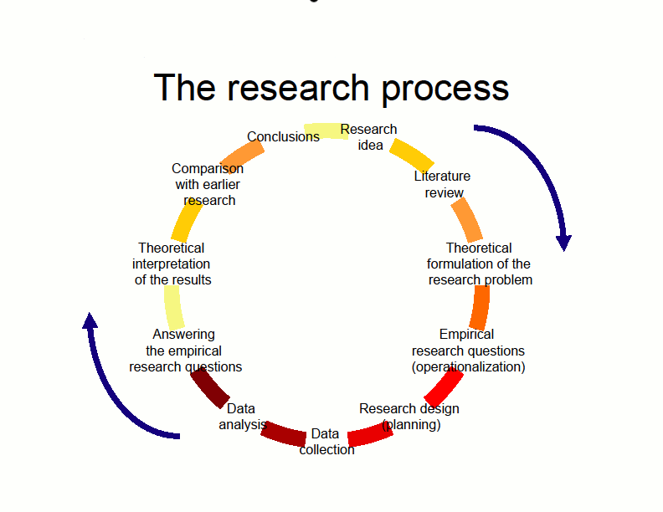

Venue- MT Hall

**About The Host Department**

The department of Economics is the earliest department in the college that started as an under graduate course in 1956. Similarly the post graduate course (M.A.) was started in 1986. The department was upgraded as a research department in 1992. It now offers M.Phil and P.hD., programmes for both men and women. So far 10 scholars have been awarded PhD., degree. The alumni of the department have occupied very important positions all over the country and aboard. The department concentrates on research and out research activities apart from the regular teaching programmes. It involves itself in undertaking various major and minor research projects sponsored by government departments and other funding agencies like UGC, ICSSR, NABARD, and MAET.

**Scene of Workshop:**

Research is getting the top most priority in higher education today. University, an abode of knowledge is expected to conduct genuine and high- quality research which has an impact on the society. Teaching and research complement each other: they should be synthesized so as to bring in relevance to the academic activity in the university. For undergoing high- quality research and writing good research papers, one requires collecting, supported by appropriate research tools and reference citation is vital for quality research work.

**Objectives of the Workshop:**

* Develop understanding on right approach towards research design and methods.
* Develop knowledge on qualitative and quantitative research methods.
* Enhance the analytical skills.
* Motivate the research scholars to write research quality articles.

**Subject Matter of the Workshop:**

Type of Research, Research Process, Research Design, Hypothesis, Sampling, Methods of data collection, Analysis of data, Testing of data, Statistical package, Report writing.

Hands-on exercises using SPSS

**Eligibility for workshop:**

Post Graduate students, M.Phil and PhD scholars from social science background are eligible to participate in this workshop.

**Instructions:**

1. Registration fee for participants is Rs.100 including food.
2. No accommodation.
3. Participants are requested to bring their own laptop without fail.
4. Candidates may apply to workshop Co-ordinator along with the duly printed registration form on or before 23nd August 2018.
5. Candidates kindly submit their registration form to Workshop Co-ordinator in hard copy duly forwarded by their Head of the Department.

**Resource Person:**

**Dr. S. Pushparaj.,M.Sc., Ph.D.**

Assistant Professor & Head,

Department of Econometrics,

Madurai Kamaraj University,

Madurai.

**For Details Contact:**

**Dr. A. Xavier Susairaj,**

Associate Professor & Head,

Workshop Co-ordinator,

Department of Economics,

Sacred Heart College (Autonomous),

Tirupattur.

**Sacred Heart College (Autonomous), Tirupattur**

**Post Graduate and Research Department of Economics**

Organizes

Workshop on

**Research Methodology in Social Sciences**

24-25 August 2018

**Registration form**

Name: Mr/Ms…………………………………………………………………………………….

Designation………………………………………………………………………………………

Academic Qualification…………………………………………………………………………..

Department……………………………………………………………………………………….

Date………………………………………………………………………………………………

**Signature of the Participant Signature with Seal of HoD**